EXERCISES
PART 6: Identities

These exercises accompany part 6 of The Stories We Live By: an online course in ecolinguistics.

Exercise 1: Ray Anderson’s story of self

The sociologist Anthony Giddens writes that:

a person’s identity is not to be found in behaviour … but in the capacity to keep a particular narrative going. The individual’s biography…must continually integrate events which occur in the external world, and sort them into the ongoing ‘story about the self’ (Anthony Giddens 1991, p. 54).

Firstly, watch Ray Anderson (who was CEO of Interface Carpets at the time), talk about how his identity changed when he became environmentally aware. Secondly, analyse the language that Anderson uses in terms of Giddens’ concept of a ‘story about the self’. The transcript is below and the video is available here:
https://www.filmsforaction.org/watch/the-corporation/

1. DATA: Transcript of Ray Anderson from The Corporation
For 21 years, I never gave a thought to what we were taking from the earth or doing to the earth in the making of our products. And then in the summer of 1994, we began to hear questions from our customers we had never heard before: “What’s your company doing for the environment?” And we didn’t have answers. The real answer was, “not very much.” And it really disturbed many of our people, not me so much as them. And a group in our research department decided to convene a taskforce and bring people from our businesses around the world to come together to assess our company’s worldwide environmental position to begin to frame answers for those customers. They asked me if I would come and speak to that group and give them a kick off speech and launch this new task force with an environmental vision— and I didn’t have an environmental vision, I did not want to make that speech. And at sort of the propitious moment, this book landed on my desk. It was Paul Hawkins book, “The Ecology of Commerce” And I began to read the “Ecology of Commerce”, really desperate for inspiration, and very quickly into that book, I found the phrase “the death of birth”. It was E.O. Wilson’s expression for species extinction, “the death of birth,” and it was a point of a spear into my chest, and I read on, and the spear went deeper, and it became an epiphanal experience, a total change of mindset for myself and a change of paradigm. One day early in this journey, it dawned on me that the way I’d been running Interface, is the way of the plunderer. Plundering something that’s not mine, something that belongs to every creature on earth, and I said to myself “My goodness, the day must come when this is illegal, when plundering is not allowed”. I mean, it must come. So, I said to myself “My goodness, some day people like me will end up in jail.

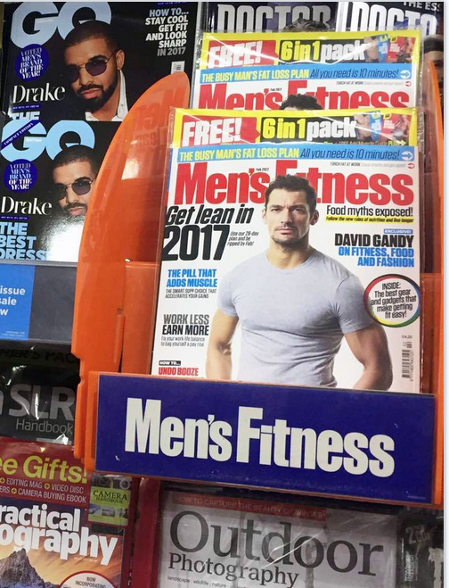
Exercise 2

Giddens also describes how material objects can become part of the story of self:

To a great or lesser degree, the project of the self becomes translated into one of possession of desired goods and the pursuit of artificially framed styles of life…. The consumption of ever-novel goods becomes in some part a substitute for the genuine development of self; appearance replaces essence as the visible signs of successful consumption come actually to outweigh the use-values of the goods and services themselves.’ (Giddens 1991, p118)

The advertisements in lifestyle magazines encourage the reader to be dissatisfied with their current identity and seek out products to create a new story of a more perfect self. Benwell and Stokoe (2006:173) analysed Cosmopolitan magazine and found a series of stories that it told about women, including a) aging is bad and must be striven against or disguised, b) fat is bad, c) body hair is bad, d) natural body odour is bad while synthetic fragrance is good, e) not wearing makeup is bad f) change and transformation of the self is good.

In this exercise, gather together lifestyle magazines and analyse how they construct identities about what it means to be an ideal man, or woman. Look particularly for stories which create problems with the current identity of the reader and present solutions in the form of consuming unnecessary and environmentally damaging products.


Exercise 3

Surfing can have a consumerist side, as advertisers encourage surfers to perform a stylish identity through purchasing branded surfing goods and accessories. However, the environmental group Surfers Against Sewage works against this consumerism and promotes environmental awareness. Looking at the quotes below from their Sustainable Guide to Surfing, discuss how Surfers Against Sewage use language in ways which resist consumerist identities and develop environmental identities.
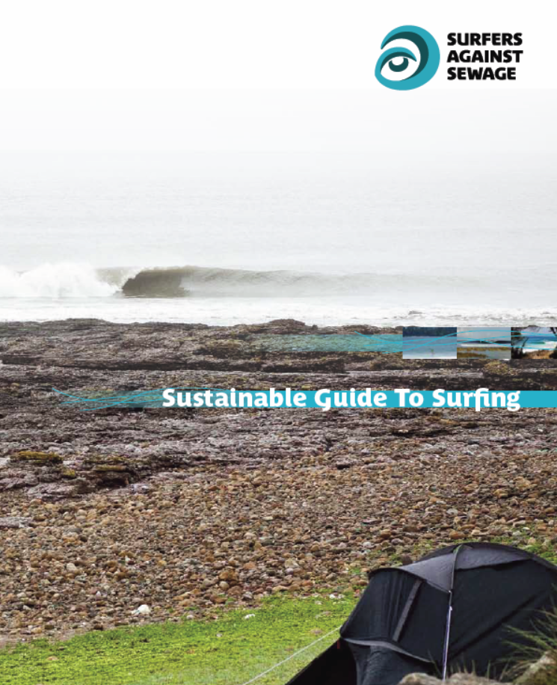
2. DATA: Sustainable Guide to Surfing (EN10)
As surfers, we are interested in being able to continue to surf, and for our children and grandchildren to be able to surf (p.8).
Any alteration in the climate and its inevitable knock-on effects, particularly on such a fragile interface such as the coast, will be severely felt by surfers (p.12).
surfers…were already living closer to nature (p.3).
as surfers, we are sensitised incrementally to the environment around us and the damage done to it (p.6).
Nowadays, surfing has turned ‘mainstream’, and our obsession with the clothes we wear and the boards we ride has almost become more important to us than the actual waves we surf (p. 46).
A surfer with a really fancy motor is…more of a poser than a proper surfer (p.32).
As surfers, we … recognise that it is possible to live happily without consuming too much energy. Surfing, stripped down to its bare essentials, actually consumes very little energy, and usually makes us extremely happy (p.19).
But surfers, although dismissed as a bunch of hippies by the rest of society, were living closer to Nature, and had already learned to appreciate things that money can’t buy (p.3).
We [surfers] realized that, if we were greedy and chose to allow our consumerist way of life to spiral out of control, we would end up ruining our own playground. (p.3)
If you stripped away all the add-ons that have been accumulating over the past 40 years or so –surf camps, jetskis, brand identification, mass-produced boards and super-stretch wetsuits that last for six months, – surfing itself would still be just as exciting as it was before. If all that stuff suddenly disappeared, it wouldn’t take away the essence of surfing, the feeling of riding a wave. (p.4)

Exercise 4

Below there are two quotes which construct identities in very different ways. Describe how the linguistic features (e.g., pronouns, assumptions, modality, and rhetorical questions) create an image of the reader. What ecological consequences might there be if readers are influenced by texts such as these to become the person described?

4. DATA
[Economics textbook] As a manager of a firm, what are you interested in? A higher salary, greater power or prestige, greater sales, better working conditions, or greater popularity with your subordinates? (ET5:12).
[Ethical investment advertisement] You may be concerned about the environment, human rights, better employment practices or promoting third world development and cooperatives. Our financial planning [takes account] of your values. We and our clients aim to make a positive difference to the world in which we all live. (EC1:10)

Further Reading

These exercises are based on examples discussed in chapter 6 of Ecolinguistics: language, ecology and the stories we live by (Arran Stibbe, 2015, Routledge).

Share what you discovered

If you would like to share insights you discovered through these exercises then you can register for the free online course Stories We Live By here: http://storiesweliveby.org.uk/register. You will then have access to discussion groups, pages you can edit, and can apply for a free certificate of completion.

References

Giddens, A., 1991. Modernity and self-identity: self and society in the late modern age. Stanford University Press.
Benwell, B. and Stokoe, E., 2006. Discourse and identity. Edinburgh University Press.
Data examples with a two letter and number tag (e.g., AG5) are from the Ecolinguistics Text Collection. Full references can be looked up by accessing the collection here (http://storiesweliveby.org.uk/references) and using the tag.

