PART 7: Convictions
EXERCISES

These exercises accompany part 7 of The Stories We Live By: an online course in ecolinguistics.

Exercise 1

Analyse the extract below from Men’s Health magazine. How does the facticity pattern decrease the facticity of the description red meat is unhealthy? What impact could this have on the readers’ convictions about the healthiness of meat? Next, analyse the extract below from the scientific paper that the Men’s Health article was based on. How is facticity pattern in the scientific paper different from the Men’s Health article?
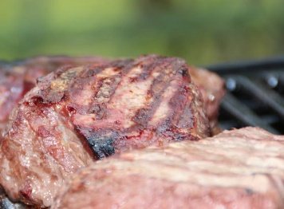

2. DATA
From Men’s Health magazine: A world leader in the fight against cancer, Dr Dashwood completed his PhD in the UK before hopping across the pond to join Oregon State University. His most recent research means you can indulge in a rare steak a little more often, without fear of retribution. Bloody heaven we say … scientists have discovered an easy way to protect yourself from the harmful effects of a sirloin – eat it with a side of spinach … Now you can have your steak and eat it (MH4:35)
From the scientific paper that the quote from Men’s Health magazine above was based: We describe here the first comprehensive screening of miRNAs altered in rat colon tumours induced by a widely consumed dietary carcinogen, PhIP…Dysregulation of these factors was partially reversed in rats consuming dietary spinach during the post-initiation period. Although the precise mechanisms await further study, the current investigation provides further support for research at the interface of epigenetics, diet, and cancer prevention (ML5).

Finally, what impact can people’s convictions about meat have on their health, the wellbeing of animals and the health of the environment?

Exercise 2
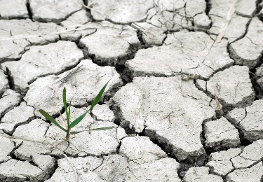
Compare the two radically different descriptions of climate change in the texts below. What linguistic devices are used to reduce or increase the facticity of the description climate change is caused by humans? How might this influence the convictions of the viewers?
What to look for:

O Calls to expert authority.

O Quantifiers such as ‘some’ or ‘many’.

O Hedges such as ‘X thinks’ or ‘X believes’

O Presuppositions, which construct descriptions as taken-for-granted

O Words which have an inbuilt comment on facticity such as fact, belief, fantasy, lie

O Modality, from highly certain (e.g., must) to highly uncertain (might)

O Metaphor, e.g., representing something as a religion reduces its facticity

O The ‘repertoire of empiricism’ which represents facts as deriving directly from the evidence without human interpretation, e.g., ‘measurements show that…’.
2. DATA: Radically different descriptions of Climate Change
From The Obama Deception: The notion of anthroprogenic global warming is a fraud. In other words, the idea that the planet is getting warmer, and that human activity is somehow responsible, is a pseudoscientific fraud. It's a big lie. It's a monstrosity. Remember the Nazis, they had race science, race hygiene. They said Aryan blood is different from any other kind of blood. This was, of course, idiocy, a fantastic piece of nonsense. Today, we've got something similar. Global warming caused by human activity. And the answer to that is carbon tax plus cap-and-trade, according to the wishes of Al Gore, Prince Charles, and basically the entire world banking community, the world oligarchy. What they're trying to do with that is to perpetuate the current system where bankers rule the world, financiers rule the world, and the rest of us get the crumbs from the table. But remember, if you try to put on cap-and-trade and a global warming carbon tax with the idea that you're gonna save the polar bears, what you're going to do is destroy human society. You're going to cause genocide on a massive scale. The deaths will be measured in the hundreds of millions and indeed, in the billions. Just the idea of global warming means there will be no development for Africa. So it's important to expose and fight the pseudoscientific fraud of global warming. Now one more point about this. You do not need a climatologist to know that this stuff is a fraud. I'm a historian, I can tell you…” (Walter Tarpley)
From the Intergovernmental Panel on Climate Change:
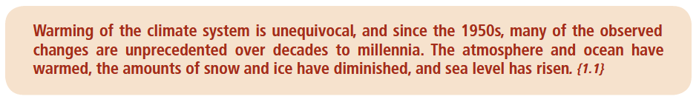

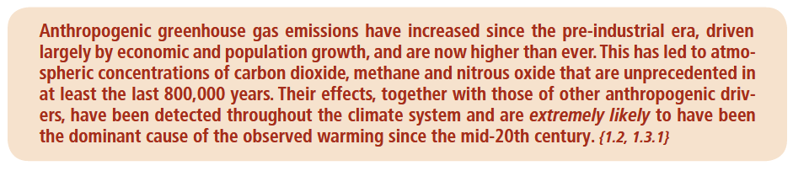

Exercise 3

New Nature Writing has an interesting mix of facticity patterns, where sometimes facticity is high because of a scientific view of the world, and sometimes facticity is high because of the certainly provided by direct personal experience. Firstly, describe the patterns of facticity in the examples of New Nature Writing below. Secondly, discuss how the combination of facticity could be useful in encouraging people to both care for the environment and take effective action.

3. DATA: Extracts from New Nature Writing
It was then that I saw the glimmering of the water. A line of blinking light – purple and silver – rimming the long curve of the beech. I walked down to the edge, squatted, and waved a hand in the water. It blazed, purple, orange, yellow and silver. Phosphorescence! (NW6:40).
It is now understood that marine phosphorescence – or, more properly, bioluminescence – is a consequence of the build-up in the water of minute organisms: dinoflagellate algae and plankton (NW6:41).
Isotope hydrology suggests that the trapped fossil water in some of the world’s largest confined aquifers is over a million years old … In comparison, this ditchwater at the river’s head was brand new (NW4:20).
There was a stinking pond at the edge of the trees, and a tractor waiting for the morning’s work. The oats had yet to ripen and everything stood very still. I could hear the faintest trickle of water pattering past roots and tiny stones (NW4:20).


Exercise 4

Watch the first 7 minutes of the climate change denial film The Great Global Warming Swindle (here). Analyse the facticity patterns to show how the filmmakers lower the facticity of the description ‘humans cause climate change’ and raise the facticity of ‘humans do not cause climate change’. Look for modality, stake, contrasts, calls to authority and word choice in representing ideas and people. It might be helpful to use two large pieces of paper, one for ‘humans cause global warming’ and one for ‘humans do not cause global warming’. The transcript below is from the first edition of the film.

4. DATA: Transcript of extracts from The Great Global Warming Swindle
Paul Reiter: We imagine that we live in an age of reason, and the global warming alarm is dressed up as science. But it's not science. It's propaganda.  Nir Shaviv: There is no direct evidence which links 20th century global warming to anthropogenic greenhouse gases.  Nigel Calder: We're just being told lies, that's what it comes down to.  Ian Clark: We can't say that CO2 will drive climate. It certainly never did in the past.  Tim Ball: If the CO2 increases in the atmosphere as a greenhouse gas, then the temperature will go up. But the ice core record shows exactly the opposite. So the most fundamental assumption of the whole theory of climate change due to humans, is shown to be wrong.  Nigel Calder: The whole thing stinks.  Narrator: Man-made global warming is no longer just a theory about climate. It is the defining moral and political cause of our age. Campaigners say the time for debate is over. Any criticism, no matter how scientifically rigorous, is illegitimate - even worse, dangerous. But in this film it will shown that the earth's climate is always changing, that there is nothing unusual about the current temperature, and that the scientific evidence does not support the notion that climate is driven by carbon dioxide, man-made or otherwise. Everywhere you are told that man- made climate change is proved beyond doubt. But you are being told lies.  Tim Ball: When people say we don't believe in global warming, I say "No, I believe in global warming, I don't believe that human CO2 is causing that warming."  Narrator: Each day the news reports grow more fantastically apocalyptic. Politicians no longer dare to express any doubt about climate change.  Narrator: Global warming has gone beyond politics - it is a new kind of morality.  [Cut to film of Jeremy Paxman on Newsnight, on BBC2]  Jeremy Paxman: Now the Prime Minister is back from his holiday; he's unrepentant and unembarrassed about yet another long haul destination.  Narrator: Yet, as the frenzy of a man-made global warming grows shriller, many senior climate scientists say the actual scientific basis for the theory is crumbling. | Nir Shaviv: There were periods for example in the earth's history when we had 3 times as much CO2 as we have today; or periods when we had 10 times as much CO2 as we have today. And if CO2 has a large effect on climate then you should see it in the temperature reconstruction.  Ian Clark: If we look at climate with a geological timeframe we would never suspect CO2 as a major climate driver.  Piers Corbyn: None of the major climate changes in the last 1000 years can be explained by CO2.  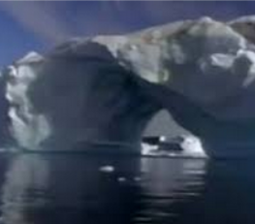  Ian Clark: We can't say that CO2 will drive climate - it's certainly never did in the past.  John Christy: I've often heard it said that there's a consensus of thousands of scientists on the global warming issue and that humans are causing a catastrophic change to the climate system. Well I am one scientist and there are many that simply think that is not true.  Narrator: Man-made global warming is no ordinary scientific theory  [Cut to film of News at Ten presenter on BBC1]  Presenter: This morning the Intergovernmental Panel on Climate Change ...  Narrator: It is presented in the media as having the stamp of authority of an impressive international organisation...  Philip Stott: The IPCC, like any UN body, is political. The final conclusions are politically driven.  Narrator: This is the story of how a theory about climate turned into a political ideology.  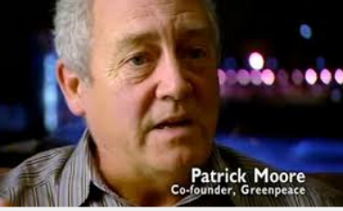  Patrick Moore: See, I don't even like to call it the environmental movement any more because really it is a political activist movement; and they have become hugely influential at a global level.  Narrator: It is the story of the distortion of a whole area of science.  Roy Spencer: Climate scientists need there to be a problem in order to get funding.  John Christy: We have a vested interest in creating panic because then money will flow to climate science.

Further Reading

These exercises are based on examples discussed in chapter 7 of Ecolinguistics: language, ecology and the stories we live by (Arran Stibbe, 2015, Routledge).

Share what you discovered

If you would like to share insights you discovered through these exercises then you can register for the free online course Stories We Live By, here: http://storiesweliveby.org.uk/register. You will then have access to discussion groups, and pages you can edit, and can apply for a free certificate of completion.

References

IPPC (2014) AR5 report. Intergovernmental Panel on Climate Change. https://www.ipcc.ch/report/ar5/syr/
NW4: Laing, O., 2011. To the river: a journey beneath the surface. Edinburgh: Canongate Books.
NW6: Macfarlane, R., 2009. The wild places. London: Granta Books.
MH4: MH, 2012. Men’s Health. UK edition. Nov.
ML5: Parasramka, M., Dashwood, W., Wang, R., Abdelli, A., Bailey, G., Williams, D., Ho, E., and Dashwood, R., 2012. MicroRNA profiling of carcinogen-induced rat colon tumors and the influence of dietary spinach. Molecular nutrition & food research, 56 (8), 1259–1269

Images:
https://www.pexels.com

